THE GREGG SHORTHAND BRIEF FORMS
(Zoubek & Condon, 1990)

 | Word  {Brief Form (text)} | Symbol
 | a, an  {[dot]} | .
2 | about  {a b} | 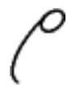
3 | acknowledge  {a k} | 
4 | advantage  {a v} | 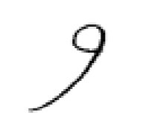
5 | advertise  {a v t i s} | 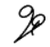
6 | after  {a f t} | 
7 | am  {m} | 
8 | and  {n d} | 
9 | anniversary  {a n e v} | 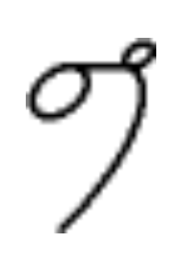
10 | any  {n e} | 
11 | appropriate  {a p r o p} | 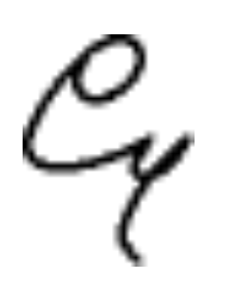
 | Word  {Brief Form (text)} | Symbol
12 | are, our, hour  {r} | 
13 | at, it  {t} | 
14 | be, by  {b} | 
15 | between  {b ten} | 
16 | business  {b s} | 
17 | but  {b t} | 
18 | can  {k} | 
19 | character  {k a k} | 
20 | circular  {s e r k} | 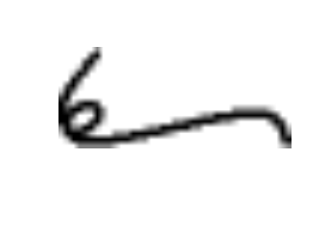
21 | circumstance  {[left s] / s ten s} | 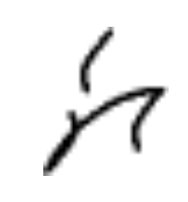
23 | company  {k p} | 
24 | convenience, convenient  {k v e n} | 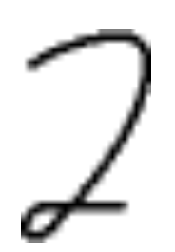
25 | correspond, -ence  {k r e s} | 
 | Word  {Brief Form (text)} | Symbol
26 | could  {k d} | 
27 | difficult  {def k} | 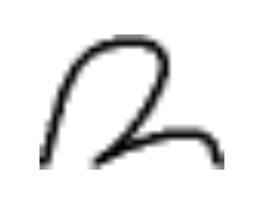
28 | direct  {d r k} | 
29 | during, Dr., doctor  {d r} | 
30 | electric  {e l (above line)} | 
31 | enclose  {n k} | 
32 | envelope  {n v l} | 
33 | equip  {e k p} | 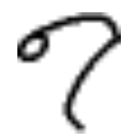
34 | equivalent  {e k [e with line under it] v} | 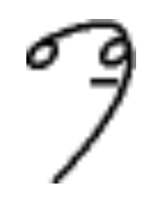
35 | ever, every  {e v} | 
36 | executive  {e s ek v} | 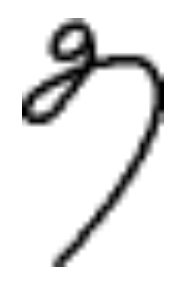
37 | experience  {e s p} | 
38 | for  {f} | 
 | Word  {Brief Form (text)} | Symbol
39 | from  {f m} | 
40 | general  {j e n} | 
41 | gentlemen  {j men} | 
42 | glad  {g l} | 
43 | good  {g} | 
44 | govern  {g v} | 
45 | have  {v} | 
46 | his, is  {s} | 
47 | out  {a u} | 
48 | however  {a u v} | 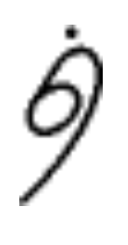
49 | I  (a} | 
50 | idea  {a d e} | 
 | Word  {Brief Form (text)} | Symbol
51 | immediate  {e m e} | 
52 | important, -tance  {m p} | 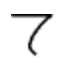
53 | in, not  {n} | 
54 | include  {e d} | 
55 | incorporate  {e nk} | 
56 | insurance, insure  {n sh} | 
57 | manufacture  {men f} | 
58 | memorandum  {m e m o} | 
59 | morning  {men [dot]} | 
60 | Mr.  {m r} | 
61 | Mrs.  {m r s} | 
62 | Ms.  {m s} | 
63 | never  {n v} | 
 | Word  {Brief Form (text)} | Symbol
64 | newspaper  {n s p} | 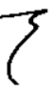
65 | next  {n e s} | 
66 | object  {o b k} | 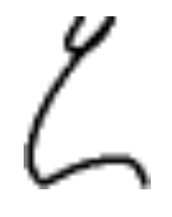
67 | of  {o} | 
68 | office  {o f} | 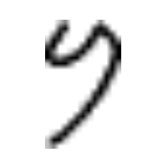
69 | opinion  {o p n} | 
70 | opportunity  {o p r} | 
71 | order  {o d} | 
72 | ordinary  {o den} | 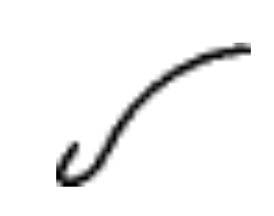
73 | organize  {o g} | 
74 | over  {o (over the line)} | 
75 | part  {p t} | 
76 | particular  {p a t} | 
 | Word  {Brief Form (text)} | Symbol
77 | present  {p r} | 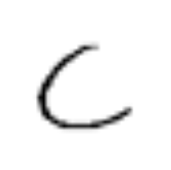
78 | privilege  {p r e v} | 
79 | probable  {p r b} | 
80 | product  {p r o d} | 
81 | program  {p r o g} | 
82 | progress  {p r g} | 
83 | property  {p r p t e} | 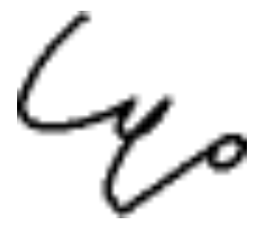
84 | public  {p b} | 
85 | publish, publication  {p b sh} | 
86 | quantity  {k t (intersected)} | 
87 | question  {k sh} | 
88 | recognize  {r k n i s} | 
 | Word  {Brief Form (text)} | Symbol
89 | recommend  {r e k} | 
90 | regard  {r e g d} | 
91 | regular  {r e g} | 
92 | reluctance  {r e l u k} | 
93 | request  {r k e s t} | 
94 | responsible  {r s p} | 
95 | satisfy, -actory  {s a t e s} | 
96 | send  {s e n} | 
97 | several  {s e v} | 
98 | short  {sh t} | 
99 | should  {sh d} | 
100 | significant, -cance  {s e g n e f} | 
 | Word  {Brief Form (text)} | Symbol
101 | soon  {s n} | 
102 | speak  {s p} | 
103 | state  {s t} | 
104 | statistic  {s t a t} | 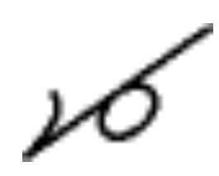
105 | street  {s t r} | 
106 | subject  {s j} | 
107 | success  {s u k} | 
108 | suggest  {s u g} | 
109 | than  {[over th] n} | 
110 | thank  {[over th] [raised dot]} | 
111 | that  {[over th] a} | 
112 | the  {[over th]} | 
 | Word  {Brief Form (text)} | Symbol
113 | their, there  {[under th]} | 
114 | them  {[over th] m} | 
115 | they  {[over th] e} | 
116 | thing, think  {[over th] [dot]} | 
117 | this  {[over th] s} | 
118 | throughout  {[under th] r a u} | 
119 | time  {t m} | 
120 | under  {u (over the line)} | 
121 | usual  {e u sh} | 
122 | value  {v l} | 
123 | very  {v e} | 
124 | was  {o s} | 
125 | well, will  {l} | 
 | Word  {Brief Form (text)} | Symbol
126 | were  {e r} | 
127 | what  {o t} | 
128 | when  {e n} | 
129 | where  {a r} | 
130 | which  {ch} | 
131 | wish  {u sh} | 
132 | with  {e [over th]} | 
133 | won, one  {u n} | 
134 | work  {r k} | 
135 | world  {u u} | 
136 | worth  {u u [over th]} | 
137 | would  {d} | 
138 | yesterday  {e s t} | 
 | Word  {Brief Form (text)} | Symbol
139 | you, your  {u}

